1. **Develop a PHP program to display prime numbers between the given range and display the total number of prime numbers.**

<!DOCTYPE html>

<html>

<head>

<title></title>

</head>

<body>

<form method="POST">

<p>

<p>Enter First Number<input type="text" name="num1" ></p>

<p>Enter Second Number<input type="text" name="num2" ></p>

<input type="submit" name="submit" value="Submit">

</form>

<?php

if(isset($_POST['submit']))

{

$num1 = $_POST['num1'];

$num2 = $_POST['num2'];

$count=0;

while($num1 < $num2)

{

$div_count=0;

for ($i=1;$i<=$num1;$i++)

{

if(($num1%$i)==0)

{

$div_count++;

}

}

if($div_count<3)

{

echo $num1."<br/> ";

$count++;

}

$num1=$num1+1;

}

echo "Total Prime Numbers = ",$count;

}

?>

</body>

</html>

**OUTPUT:**

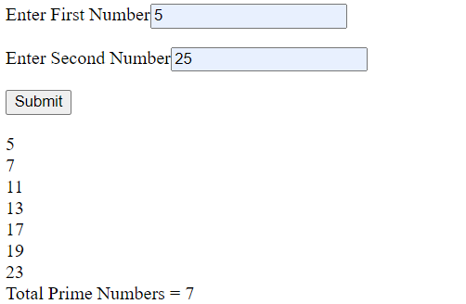

1. **Develop a PHP program and check message passing mechanism between pages.**

**File Name: second.php**

<!DOCTYPE html>

<html>

<head>

<title>Message Passing Mechanism</title>

</head>

<body>

<form action="messages.php" method="POST">

<p>Enter Name:<input type="text" name="name"></p>

<p>Enter Semester:

<select name="sem">

<option>First</option>

<option>Second</option>

<option>Third</option>

<option>Fourth</option>

<option>Fifth</option>

<option>Sixth</option>

</select>

</p>

<p>Gender:</p>

<p>Male: <input type="radio" name="gender" value="Male">

Female: <input type="radio" name="gender" value="Female">

</p>

<p>Select Subject:

<select name="subject">

<option>C</option>

<option>C++</option>

<option>Java</option>

<option>PHP</option>

</select>

</p>

<input type="submit" name="submit" value="Submit">

</form>

</body>

</html>

**File Name: messages.php**

<?php

if(isset($_POST['submit']))

{

$name = $_POST['name'];

$sem = $_POST['sem'];

$gender = $_POST['gender'];

$subject = $_POST['subject'];

echo "<br/>Name :",$name;

echo "<br/>Semester: ",$sem;

echo "<br/>Gender: ",$gender;

echo "<br/>Subject :",$subject;

}

?>

**OUTPUT:**

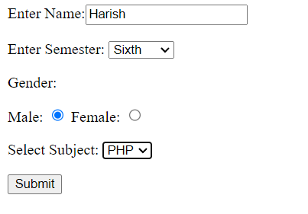

**After Click on Submit Button**



1. **Write a PHP program to implement simple calculator operations**

<!DOCTYPE html>

<html>

<head>

<title>Simple Calculator</title>

</head>

<body>

<form method="POST">

<p>

<p>Enter First Number<input type="text" name="num1" value="<?php if (isset($_POST['num1'])) echo $_POST['num1']; ?>" ></p>

<p>Enter Second Number<input type="text" name="num2" value="<?php if (isset($_POST['num2'])) echo $_POST['num2']; ?>" ></p>

<input type="submit" name="add" value="Add(+)">

<input type="submit" name="sub" value="Sub(-)">

<input type="submit" name="mul" value="Mul(x)">

<input type="submit" name="div" value="Div(/)">

<input type="submit" name="mod" value="Mod(%)">

</form>

<?php

if(isset($_POST['add']))

{

echo "Addition = ",$_POST['num1'] + $_POST['num2'];

}

elseif(isset($_POST['sub']))

{

echo "Subtraction = ",$_POST['num1'] - $_POST['num2'];

}

elseif(isset($_POST['mul']))

{

echo "Multiplication = ",$_POST['num1'] * $_POST['num2'];

}

elseif(isset($_POST['div']))

{

echo "Division = ",$_POST['num1'] / $_POST['num2'];

}

elseif(isset($_POST['mod']))

{

echo "Modulus = ",$_POST['num1'] % $_POST['num2'];

}

?>

</body>

</html>

**OUTPUT:**

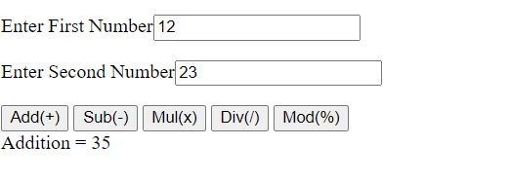

1. **Develop a PHP program to demonstrate String functions. (any 6).**

<html>

<body>

<form method="POST">

<p>Assignment 4 - String Built-In Methods</p>

<ol>

<li>Length of String </li>

<li>Number of Words in String</li>

<li>String Reverse</li>

<li>String Replace</li>

<li>String Uppecase</li>

<li>String Lowercase</li>

</ol>

<p><input type="text" name="num"></p>

<p><input type="submit" name="submit" value="Submit"></p>

</form>

<?php

if(isset($_POST['submit']))

{

$str1="GSS College";

$str2="This is web programming!";

$str3="this is php ! well yes this is php ";

echo "String1 is = ".$str1;

echo "<br/> String2 is = ".$str2;

echo "<br/> String3 is = ".$str3;

echo "<br/>";

$num = $_POST['num'];

switch ($num) {

case '1':

echo "<br/><br/>Length of string 1 is =" .strlen($str1);

break;

case '2':

echo "<br/>The number of words in string2 are ".str_word_count($str2);

break;

case '3':

echo "<br/>The reverse of string1 is ".strrev($str1);

break;

case '4':

echo "<br/>The word php in string3 is replaced with web :".str_replace("php","web",$str3);

break;

case '5':

echo "<br/> converting string3 to uppercase : " .strtoupper($str3);

break;

case '6':

echo "<br/> converting string1 to lowercase : " .strtolower($str1);

break;

default:

echo "Please Enter Valid Number";

break;

}

}

?>

</body>

</html>

**OUTPUT:**

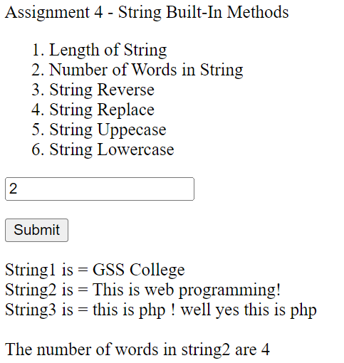

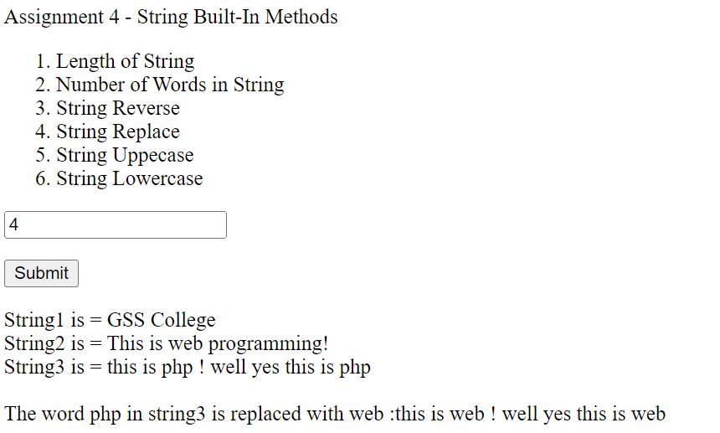

1. **Write a PHP program to illustrate built in Array manipulation functions.(any 6)**

<html>

<body>

<form method="POST">

<p>Assignment 5 - Array Manipulation</p>

<ol>

<li>Size of Array</li>

<li>Array Merge (Array 1, Array2)</li>

<li>Sort Array1 (Ascending &Descending)</li>

<li>Array2 Reverse Order</li>

<li>Array to String implode()</li>

<li>Common elements in two arrays</li>

</ol>

<p>Enter your choice [1 to 6]</p>

<p><input type="text" name="num"></p>

<p><input type="submit" name="submit" value="Submit"></p>

</form>

<?php

if(isset($_POST['submit']))

{

$array1 = array("GSS","BCA","College");

$array2 = array("p"=>"GSS","q"=>"BSC","r"=>"College","s"=>"Belagavi");

echo "<br>Array1 :<br>";

print_r($array1);

echo "<br>Array2 :<br>";

print_r($array2);

echo "<br>";

$num = $_POST['num'];

switch ($num) {

case '1':

echo "<br>Size of the array1 is: ". sizeof($array1);

echo "<br>Size of the array2 is: ". sizeof($array2);

break;

case '2':

$merged = array_merge($array1, $array2);

echo "<br> Merge array1 and array2<br>";

print_r($merged);

break;

case '3':

echo "<br>Sorted array in Ascending order<br>";

sort($array1);

foreach ($array1 as $key => $value) {

echo $value,"<br>";

}

echo "<br>Sorted array in Descending order<br>";

rsort($array1);

foreach ($array1 as $key => $value) {

echo $value,"<br>";

}

break;

case '4':

echo "<br>Array2 in Reverse order<br>";

$reverse = array_reverse($array2);

foreach ($reverse as $key => $value) {

echo $value,"<br>";

}

break;

case '5':

echo "Array 1 to String :";

$str = implode('$array1);

echo "$str";

break;

case '6':

echo "Common elements form Array1 & Array2";

$common = array_intersect($array1, $array2);

print_r($common);

break;

default:

echo "Please Enter Valid Number";

break;

}

}

?>

</body>

</html>

**OUTPUT:**

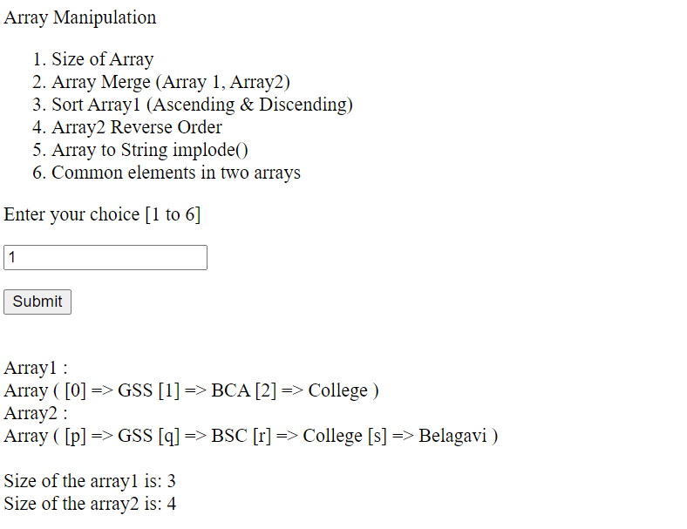

1. **Write a PHP program that displays a different message based on time of day. For example page should display “Good Morning” if it is accessed in the morning**

<html>

<head>

<title>PHP Program for Displaying Greeting depending upon Current Time Zone</title>

<style>

font

{

background-color:blue;

font-family:"cursive","lucida handwriting";

}

</style>

</head>

<body>

<h3> Assignment 6 - Displaying Greeting depending upon Current Time Zone</h3>

<?php

date_default_timezone_set("Asia/Kolkata");

echo "Today is :" ;

echo date("jS F Y");

echo "</br> Current time is :" ;

echo date("G:i:s a");

$h = date('G');

if($h<12)

{

echo " </br><font> Good morning </font>";

}

else if($h>=12 && $h<16)

{

echo "</br> <font> Good afternoon </font> ";

}

else if($h>=16 && $h<=19)

{

echo "</br> <font> Good evening </font> ";

}

else

{

echo "</br> <font>Good Night</font>";

}

?>

</body>

</html>

**OUTPUT:**

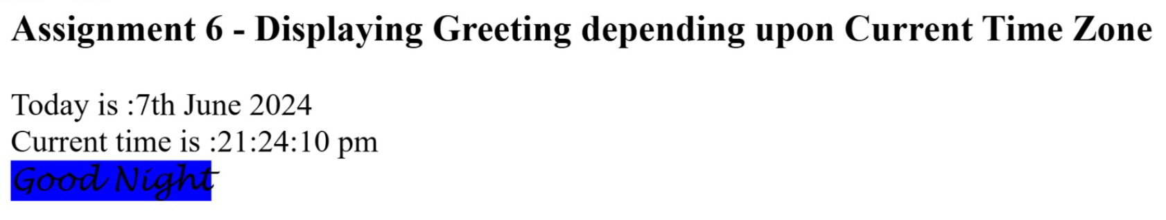

1. **Write a PHP program that accepts two numbers using a web form and calculates greatest common divisor (GCD) and least common multiple (LCM) of entered numbers.(Use recursive function)**

<!DOCTYPE html>

<html>

<head>

<title>GCD & LCM</title>

</head>

<body>

<form method="post">

<p>Enter First Number :<input type="text" name="num1" value="<?php if (isset($_POST['num1'])) echo $_POST['num1']; ?>" required></p>

<p>Enter Second Number :<input type="text" name="num2" value="<?php if (isset($_POST['num2'])) echo $_POST['num2']; ?>" required></p>

<p><input type="submit" name="submit" value="Submit"></p>

</form>

</body>

</html>

<?php

if(isset($_POST['submit']))

{

$x = $_POST['num1'];

$y = $_POST['num2'];

function gcd($x, $y) {

if ($y == 0)

return $x;

return gcd($y, $x%$y);

}

$lcm = ($x*$y)/gcd($x,$y);

echo "LCM of $x and $y is: $lcm <br>";

echo "GCD of $x and $y is: ".gcd($x,$y);

}

?>

**OUTPUT**

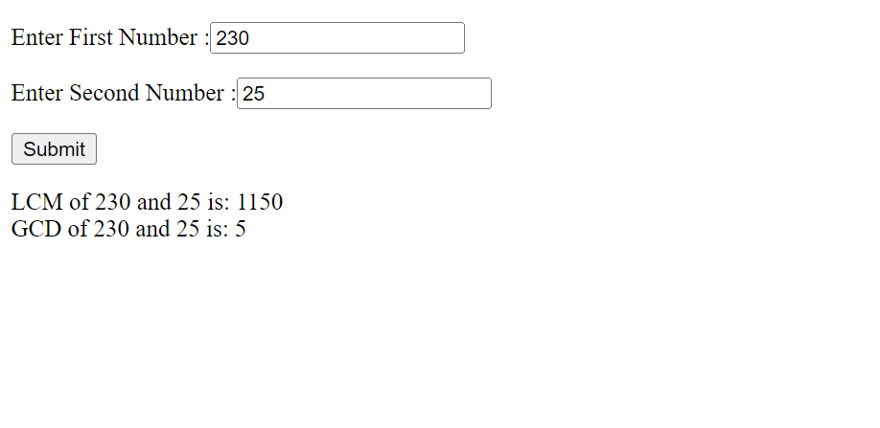

1. **Develop a PHP program to demonstrate constructors and destructors.**

<?php

echo "Assign 8 - using constructors and destructors ";

//create a class called member

class Member

{

private $username;

private $location;

private $homepage;

//write the constuctor method

public function __construct( $username, $location, $homepage )

{

$this->username = $username;

$this->location = $location;

$this->homepage = $homepage;

echo "<br/> <br/> Object initialized ";

}

//display the initialized object properties

public function showProfile()

{

echo "<dl>";

echo "<dt>Username:</dt> <dd>$this->username</dd>";

echo "<dt>Location:</dt> <dd>$this->location</dd>";

echo "<dt>Homepage:</dt> <dd>$this->homepage</dd>";

echo "</dl>";

}

public function __destruct()

{

echo "Object destroyed... Bye!!!";

}

}// end of class

//create a new object

$aMember = new Member( "Rasmus", "Greenland", "http://www.php.net/" );

//display the member profile

$aMember->showProfile();

//remove the object

unset($aMember);

?>

**OUTPUT**

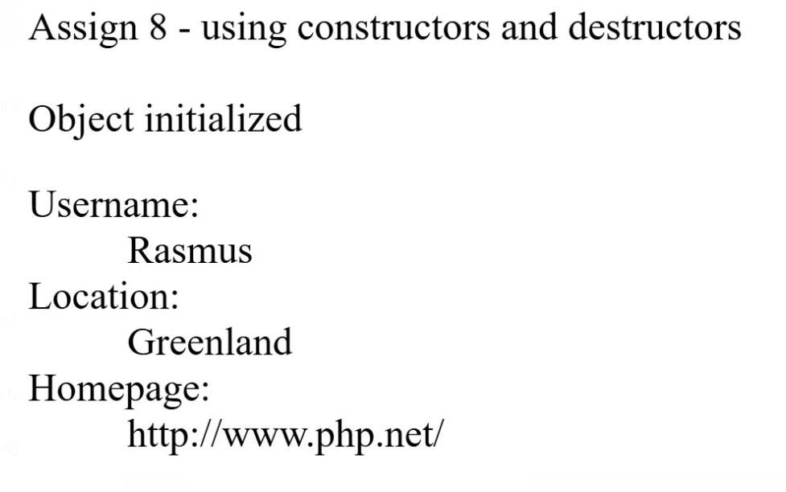

1. **Develop a PHP code to read the values entered into the form using the MySQL database**

<!DOCTYPE html>

<html>

<head>

<title>PHP MYSQL</title>

</head>

<body>

<?php $conn = mysqli_connect('localhost','root','','mydatabase') ?>

<form method="post">

<table>

<tr>

<td colspan="2" style="text-align: center">STUDENTS DATA</td>

</tr>

<tr>

<td>ENTER UUCMS NO</td>

<td><input type="text" name="uucms"></td>

</tr>

<tr>

<td>ENTER NAME</td>

<td><input type="text" name="name"></td>

</tr>

<tr>

<td>ENTER SEMESTER</td>

<td><select name='semester'>

<option>FIRST</option>

<option>SECOND</option>

<option>THIRD</option>

<option>FOURTH</option>

<option>FIFTH</option>

<option>SIXTH</option>

</select></td>

</p>

</tr>

<tr>

<td>ENTER GENDER</td>

<td>MALE<input type="radio" name="gender" value="Male">

FEMALE<input type="radio" name="gender" value="Female"></td>

</tr>

<tr>

<td colspan="2" style="text-align: center"><input type="submit" name="submit" value="SUBMIT"></td>

</tr>

</form>

</table>

<?php

if(isset($_POST['submit']))

{

$uucms = $_POST['uucms'];

$name = $_POST['name'];

$semester = $_POST['semester'];

$gender = $_POST['gender'];

$query = mysqli_query($conn, "INSERT INTO student(uucms_no,name,semester,gender) VALUE('$uucms','$name','$semester','$gender')");

if($query){

echo "<script>alert('Record Inserted')</script>";

}

}

?>

<table border="1px">

<tr>

<th>SL NO</th>

<th>UUCMS NO</th>

<th>NAME</th>

<th>SEMESTER</th>

<th>GENDER</th>

</tr>

<tr>

<?php

$ret=mysqli_query($conn,"select * from student");

$cnt=1;

while ($row=mysqli_fetch_array($ret)){

?>

<td>

<?php echo $cnt; ?>

</td>

<td>

<?php echo $row['uucms_no']; ?>

</td>

<td>

<?php echo $row['name']; ?>

</td>

<td>

<?php echo $row['semester']; ?>

</td>

<td>

<?php echo $row['gender']; ?>

</td>

</tr>

<?php

$cnt = $cnt + 1;

} ?>

</table>

</body>

</html>

**OUTPUT:**

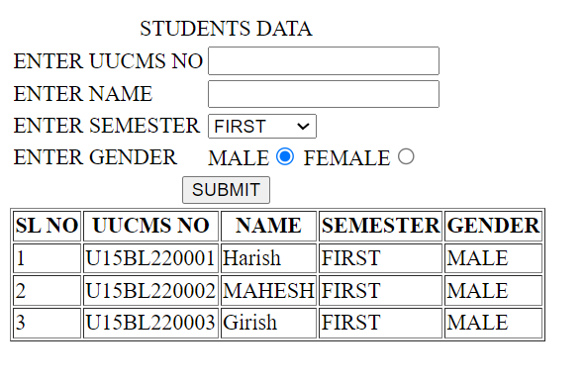

1. **Create Laravel Project using composer display Simple “Hello World” Message on Web page.**



<!DOCTYPE html>

<html>

<head>

<title>Hello World</title>

</head>

<body>

<h1 style="color: blue">GSS COLLEGE</h1>

<h3 style="color: blue">BCA DEPARTMENT</h3>

<h3 style="color: blue">BELAGAVI</h3>

</body>

</html>



<?php

use Illuminate\Support\Facades\Route;

Route::get('/', function () {

return view('hello-world');

});

**Type:** php artisan serve

To run server

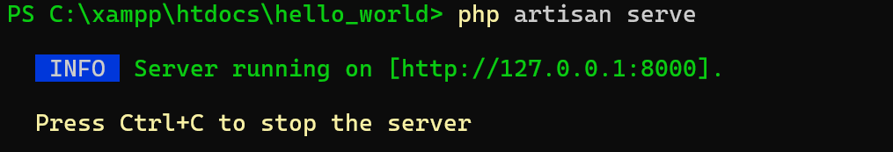

**OUTPUT:**

